Name=anok

Batch =125

[Gmail=anokay14@gmail.com](mailto:Gmail=anokay14@gmail.com)

**S3 BUCKET-: Today topic is cross region replication.**

SOURCE BUCKET -:

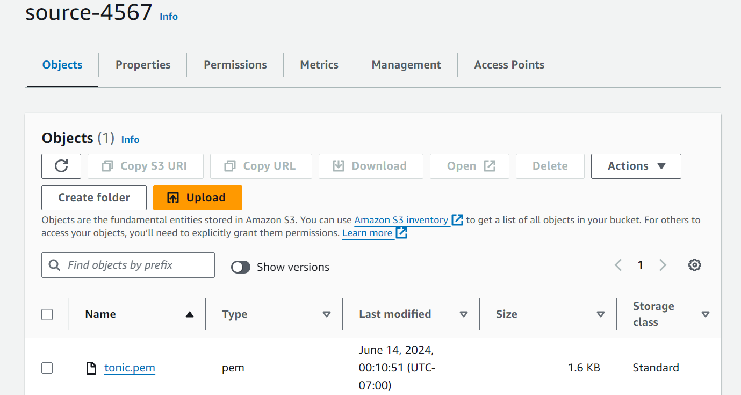

DESTINATION BUCKET-:

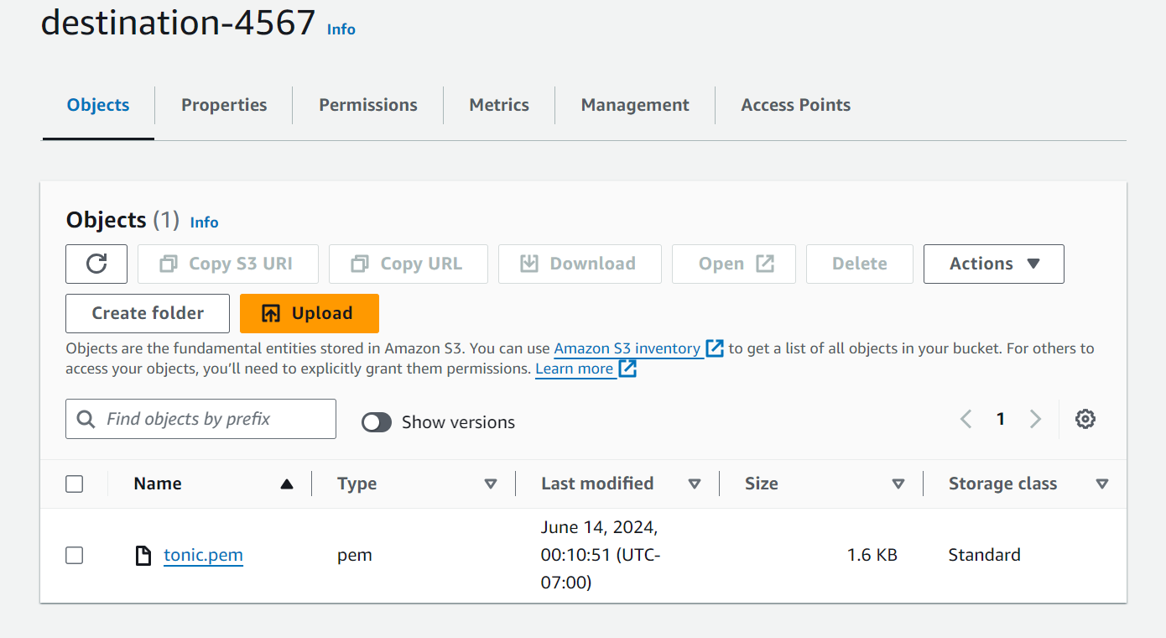

REPLICATION SOURCE-:

